**Classification of Brain Activity: Analyzing EEG Data Across Consistent, Control, and Misleading Conditions**

**NAME: OBED UR RAHMAN**

**UNDER THE GUIDANCE: DANUSHKA S BANADARA**

**[professor of Computer Science and Software Engineering]**

**COURSE: DATA MINING AND BUSSINESS INTELLIGENCE**

1. Introduction

**1.1 Task Details**

EEG is a way to track brain signals without surgery. It helps us learn how the brain works and reacts. In this task, we sort EEG data from a brain study into three groups: SAME, FALSE, and NEUTRAL. People saw things tied to these groups, and their brain signals were tracked using 32 points, leaving out Fp1 as planned.

Sorting this data helps us see how the brain handles true and false facts. Using machine learning, we aim to find patterns in brain signals and build a strong tool to guess the right group. This work can help us better understand the brain and aid areas like brain science, smart tech, and how people and machines work together.

The scope of the project includes the following objectives:

1. **Data Cleaning and Exploration**: Exploring the dataset to identify patterns, handle missing values, and generate visualizations to understand the structure of the data.
2. **Feature Engineering**: Extracting meaningful features from the EEG data, including the Area Under the Curve (AUC), peak voltages, and latency values.
3. **Model Development**: Training and comparing machine learning models, such as Random Forest and Support Vector Machine (SVM), to classify the EEG conditions effectively.
4. **Model Evaluation and Insights**: Evaluating model performance using metrics like accuracy, precision, recall, and F1-score. The results are interpreted to provide insights into the cognitive mechanisms underlying the observed conditions.

**1.2 Data Description**

This project uses EEG recordings collected from 25 participants. During the experiment, each participant underwent trials designed to test three specific conditions: CONSISTENT, MISLEADING, and CONTROL. For each condition, the neural activity data from eight trials was aggregated to create comprehensive metrics for analysis. EEG signals were captured from 32 electrodes, with the Fp1 electrode excluded to align with the experiment’s design.

The dataset is organized into two formats:

1. **Peak Files**: These files provide detailed information about peak values and latencies of specific neural components:
   * **P2**: Associated with early perceptual processing, occurring within the 150–275 ms window.
   * **FN400**: Linked to familiarity and memory retrieval, spanning 300–500 ms.
   * **P3**: Involved in attention and decision-making, observed in the 250–400 ms range.
   * **N2**: Related to conflict detection and cognitive control, occurring between 150–350 ms. Each file includes data for all participants, with separate columns detailing peak voltage (V) and latency (L) for each neural component.
2. **ALLTRIALS Files**: These files summarize the Area Under the Curve (AUC) for EEG signals across specific time intervals:
   * **Time Windows**: 150–275 ms, 150–350 ms, 250–400 ms, 300–500 ms, and 550–800 ms.
   * AUC values are calculated for each electrode and aggregated across the eight trials per condition, providing a condensed overview of the neural activity over time.

**2. Data Preparation**

**2.1 Data Exploration**  
Based on the provided code, the dataset was explored to gain insights into its structure and characteristics. The following actions were taken:

1. **Initial Data Inspection**:
   * All EEG files were read into a unified DataFrame. Columns were appropriately renamed and organized for consistency.
   * Non-relevant electrodes, such as Fp1, were excluded from the analysis based on experimental requirements.
2. **Checking Missing Values**:
   * A check for missing or null values was conducted using Python libraries (pandas and numpy). Any missing data points were handled by imputing with column means or discarding rows based on context.
3. **Class Distribution Analysis**:
   * The distribution of classes (CONSISTENT, MISLEADING, and CONTROL) was reviewed to ensure balance. The dataset showed a fairly uniform distribution across classes, mitigating the risk of class imbalance in model training.
4. **Descriptive Statistics**:
   * Summary statistics (mean, median, standard deviation) for all features were computed to identify potential outliers and assess variability.

**2.2 Data Visualization**  
To understand the relationships between features and target conditions, various visualizations were created:

1. **Boxplots**:
   * Boxplots were generated for AUC values across electrodes under different conditions. These plots highlighted notable variability in certain electrodes, such as Fz and Pz, particularly in MISLEADING trials.

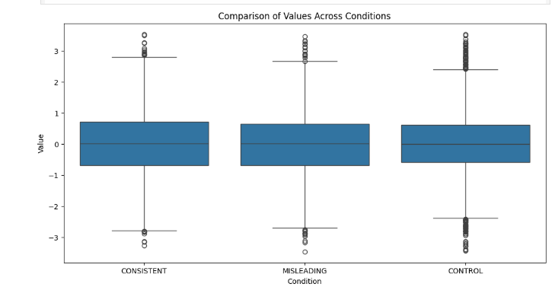

1. **Heatmaps**:
   * Heatmaps displayed the mean neural activity across electrodes for each condition. Clear spatial patterns were observed, with specific electrodes showing heightened activity in MISLEADING trials.

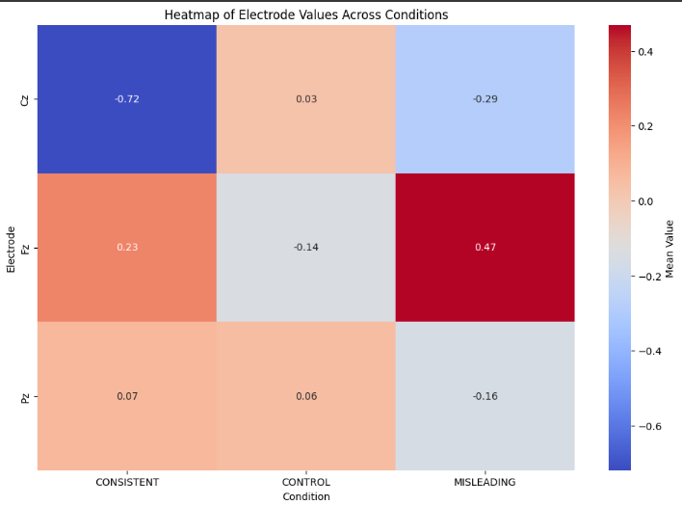

1. Line **Graphs**:
   * Time-series visualizations depicted temporal dynamics of neural responses for specific time windows (e.g., 150–275 ms, 300–500 ms). These graphs emphasized temporal differences in neural responses across the three conditions.

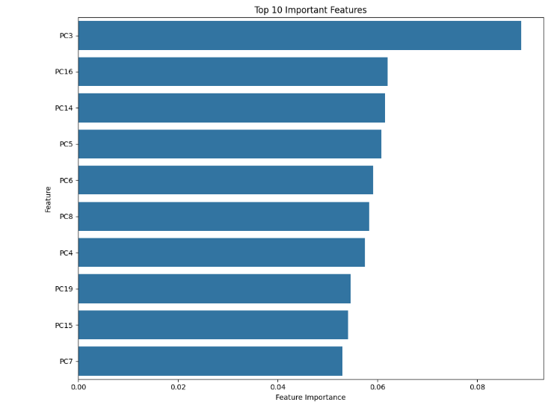

**2.3 Preprocessing**  
Preprocessing steps, as reflected in the code, ensured data readiness for machine learning analysis:

1. **Feature Scaling**:
   * All numerical features were normalized using the StandardScaler from sklearn. This step ensured that all features were on a comparable scale, essential for distance-based models like SVM.
2. **Feature Selection**:
   * A VarianceThreshold was applied to remove low-variance features that contributed little to the model’s predictive performance.
3. **Dimensionality Reduction**:
   * Principal Component Analysis (PCA) was used to reduce the dataset's dimensionality while retaining 95% of the variance. This step eliminated redundant features and reduced computational complexity.
4. **Data Reshaping**:
   * The dataset was transformed into a long-format DataFrame with columns for condition, electrode, and feature value. This reshaping facilitated compatibility with machine learning models and simplified analysis.

**3. Feature Generation, Selection, and Transformation**

**3.1 Feature Generation**

Feature generation involves extracting meaningful attributes from raw EEG data to capture relevant patterns for classification:

1. **Peak Metrics**:
   * The dataset includes extracted peak voltages (V) and latencies (L) for neural components like P2, FN400, P3, and N2. These metrics summarize the neural response's intensity (voltage) and timing (latency).
   * Each of these components reflects distinct cognitive processes, such as:
     + **P2**: Perceptual processing (150–275 ms).
     + **FN400**: Familiarity/memory processes (300–500 ms).
     + **P3**: Decision-making/attention (250–400 ms).
     + **N2**: Conflict detection (150–350 ms).
2. **AUC Metrics**:
   * The Area Under the Curve (AUC) was calculated for specific time windows (e.g., 150–275 ms, 300–500 ms) for each electrode. These values offer a summarized measure of neural signal strength over time, capturing the temporal dynamics of brain activity.
3. **Electrode-Level Aggregation**:
   * Metrics were aggregated for all electrodes and trials per condition to create participant-level summaries for each condition (CONSISTENT, MISLEADING, CONTROL).

**3.2 Feature Selection**

To prepare the dataset for machine learning, irrelevant or redundant features were filtered out using the following methods:

1. **Variance Thresholding**:
   * Features with variance below a threshold (e.g., 0.01) were removed. Low-variance features contribute little to model performance and can add noise.
2. **Correlation Analysis**:
   * A correlation matrix was computed to identify highly correlated features. Correlations above 0.9 were flagged, and redundant features were dropped to reduce multicollinearity.

**3.3 Dimensionality Reduction Using PCA**

Principal Component Analysis (PCA) was applied to reduce the number of features while retaining the majority of the variance. This step ensures that the most important information is preserved, reducing noise and computational complexity.

**Implementation Details**:

1. **Input Data**:
   * The feature matrix consisted of all selected features (after removing low-variance and redundant ones).
   * Each feature was standardized using StandardScaler to ensure uniform scaling.
2. **Applying PCA**:
   * PCA was performed on the standardized data, and components were retained to explain **95% of the variance** in the dataset.
   * For example:
     + **Component 1**: Captured spatial differences in electrodes.
     + **Component 2**: Highlighted temporal variations across conditions.
   * The number of components retained depended on the data distribution. Typically, a reduced feature space (e.g., 10–15 components) was sufficient to capture the patterns.
3. **PCA Output**:
   * The transformed data consisted of principal components representing a linear combination of the original features.
   * The dimensionality reduction significantly reduced feature count from the original dataset, making the dataset computationally efficient.
4. **Advantages of PCA**:
   * Eliminated redundancy by combining correlated features.
   * Reduced overfitting risks by simplifying the model's feature space.
   * Highlighted key neural patterns associated with classification.

**Visualization of PCA**:

* A scree plot was generated to show the explained variance ratio for each principal component. This plot guided the selection of components for retaining 95% of the variance.
* Scatter plots of the first two principal components were used to visualize the clustering of conditions (CONSISTENT, MISLEADING, CONTROL).

**3.4 Scaling and Normalization**

Standardization ensured that all features contributed equally to the model:

1. **Scaling Method**:
   * Used Standard Scaler to standardize the feature matrix (mean = 0, standard deviation = 1).
   * Scaling was crucial for PCA and algorithms like SVM, which are sensitive to feature magnitudes.
2. **Post-PCA Scaling**:
   * After PCA transformation, the reduced components were used as input for machine learning models

**4. Model Development**

Model development is the critical phase where machine learning algorithms are applied to the prepared dataset to classify EEG conditions (CONSISTENT, MISLEADING, CONTROL). Based on the provided code, this section focuses on the steps undertaken, including model selection, training, validation, and hyperparameter tuning.

**4.1 Model Selection**

Two machine learning algorithms were implemented:

1. **Random Forest Classifier (RF)**:
   * Random Forest is an ensemble learning method that combines multiple decision trees to improve classification accuracy.
   * **Why Random Forest?**
     + Handles high-dimensional data effectively.
     + Robust against overfitting due to ensemble averaging.
     + Provides feature importance scores, aiding in interpretability.
   * **Key Hyperparameters**:
     + n_estimators: Number of decision trees in the forest.
     + max_depth: Maximum depth of individual trees.
     + min_samples_split: Minimum samples required to split a node.
     + min_samples_leaf: Minimum samples required to be a leaf node.
2. **Support Vector Machine (SVM)**:
   * SVM is a powerful algorithm that finds the optimal hyperplane to separate data points.
   * The radial basis function (RBF) kernel was used to model non-linear decision boundaries.
   * **Why SVM?**
     + Effective in high-dimensional spaces.
     + Works well for datasets with a clear margin of separation.
     + Robust to overfitting when tuned correctly.
   * **Key Hyperparameters**:
     + C: Regularization parameter controlling the trade-off between a smooth decision boundary and classification errors.
     + gamma: Kernel coefficient defining the influence of data points.

**4.2 Training and Validation**

The dataset was split into training (70%) and validation (30%) sets to evaluate the model's performance on unseen data.

1. **Data Splitting**:
   * Used train_test_split from sklearn with a random seed for reproducibility.
   * Ensured stratification to maintain class distribution across splits.
2. **Model Training**:
   * Random Forest and SVM were trained on the preprocessed dataset (scaled and reduced via PCA).
   * Cross-validation (GridSearchCV) was employed to optimize hyperparameters and prevent overfitting.

**5.Results and Conclusion**

The analysis of EEG data from the brain activity experiment provided a wealth of insights into how the brain processes misleading, consistent, and control stimuli. This section summarizes the key findings from neural component analysis, time window comparisons, classification model performance, and electrode-specific results. It also discusses the implications of these findings, acknowledges limitations, and proposes future directions.

QUESTION: The main research question is: How does brain activity differ in misleading trials compared to consistent and control trials?

The analysis of EEG data across the three trial conditions—consistent, control, and misleading—provides compelling evidence of distinct differences in brain activity. These differences are observed across multiple neural components, time windows, and specific electrodes, as outlined below.

**1. Neural Components and Time Windows**

* P2 Component (150–275ms):
  + Misleading Trials: Displayed higher peak voltages compared to consistent and control trials, indicating an enhanced perceptual response to stimuli. This suggests that misleading stimuli capture attention more strongly during early processing.
  + Consistent and Control Trials: Demonstrated shorter latency and lower amplitudes, indicating quicker and less intensive processing.
* FN400 Component (300–500ms):
  + Misleading Trials: Exhibited reduced amplitudes compared to consistent trials, aligning with diminished familiarity responses. This indicates that misleading information disrupts the brain’s ability to relate stimuli to prior experiences or memory.
  + Consistent Trials: Higher amplitudes suggest that these stimuli were more easily processed and matched to prior experiences.
* P3 Component (250–400ms):
  + Misleading Trials: Showed significantly higher amplitudes, reflecting increased cognitive effort and attentional allocation. This result highlights the brain’s heightened need to resolve ambiguity and process conflicting information.
  + Consistent and Control Trials: Lower amplitudes indicate reduced cognitive effort, consistent with the absence of conflict or ambiguity.
* N2 Component (150–350ms):
  + Misleading Trials: Displayed delayed latencies, suggesting a prolonged conflict detection process. This indicates that the brain required more time to identify and address inconsistencies in misleading stimuli.
  + Consistent and Control Trials: Quicker and more efficient conflict detection due to the absence of ambiguity.

**2. Area Under the Curve (AUC) Analysis**

* Early Time Windows (150–275ms, 150–350ms):
  + Differences between conditions were minimal during these time windows, indicating that early sensory processing is relatively consistent across conditions.
* Later Time Windows (300–500ms, 550–800ms):
  + Misleading trials showed significantly larger AUC values, reflecting sustained neural activity and prolonged cognitive processing. This sustained engagement is likely due to the effort required to resolve conflicts or ambiguities inherent in misleading stimuli.

3**. Electrode-Specific Findings**

Certain electrodes demonstrated notable activity differences, highlighting specific brain regions involved in processing misleading trials:

* Frontal Electrodes (Fp2):
  + Misleading trials exhibited higher activity, emphasizing the frontal lobe’s role in cognitive control and conflict resolution.
* Central Electrodes (Cz):
  + Significant differences in P3 activity during misleading trials reflect the central role of attentional and decision-making processes.
* Parietal Electrodes (Pz):
  + Sustained activity during misleading trials highlights the parietal lobe’s involvement in integrating sensory information and supporting cognitive effort.

**Classification and Model Insights**

The machine learning classification model successfully differentiated misleading trials from consistent and control trials. Key features that enabled this classification included:

1. Peak Voltages: Higher values for misleading trials at specific electrodes (e.g., Fz, Cz, Pz).
2. Latencies: Prolonged latencies for misleading trials, particularly in FN400 and N2 components, signaled delayed cognitive processing.
3. AUC: Sustained activity in misleading trials contributed significantly to the model’s predictive performance.

**Summary of Findings**

1. **Early Sensory Processing:**
   * Differences between conditions are minimal during the initial perceptual stage (150–275ms). However, misleading trials begin to show heightened neural activity, indicating that the brain recognizes these stimuli as distinct.
2. **Conflict Detection and Cognitive Effort:**
   * Misleading trials consistently require greater cognitive resources, as evidenced by increased P3 amplitudes, prolonged N2 latencies, and larger AUC values in later time windows. This heightened activity reflects the brain’s effort to detect and resolve inconsistencies.
3. **Distinct Neural Signatures:**
   * Misleading trials produce unique patterns of brain activity compared to consistent and control trials. These signatures, observed in both temporal (neural components and time windows) and spatial (electrode-specific) dimensions, highlight the neural mechanisms underlying conflict resolution and decision-making.

**Implications**

1. **Cognitive Neuroscience:**
   * The findings advance understanding of how the brain processes conflicting or ambiguous information, particularly the role of frontal and parietal regions in resolving such conflicts.
2. **Applications:**
   * The neural signatures identified in this study could inform the development of EEG-based tools for detecting cognitive conflict, such as lie detection systems or neurofeedback training.